Additional Resources for Veterans
The Overwatch Collective (T.O.C.)
Podcast and Non-Profit Supporting Mental Health among First Responders, Military, and Families
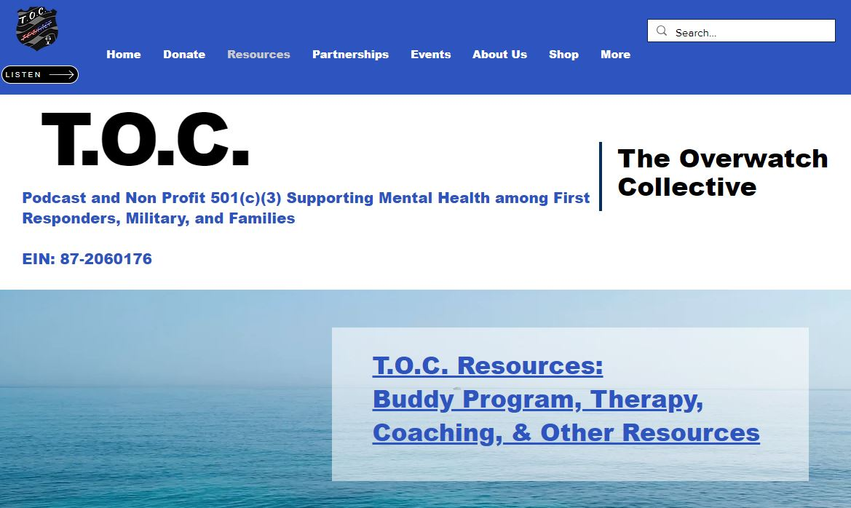
TOC Resources & Family

ReST 4 VETS – (Resilience, Strength, Time) 4 VETS helps Veterans connect through online group sessions. This organization is run by Volunteers of America (VOA).
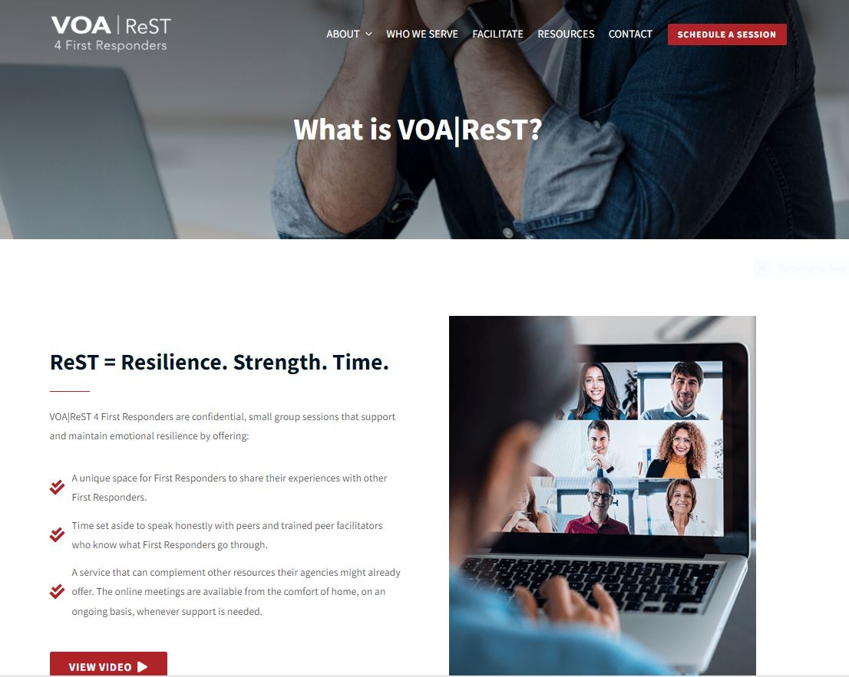
VOA|ReST 4 First Responders offers free, peer-to-peer small group support sessions designed to help First Responders process feelings of moral discomfort and distress while reclaiming strength and commitment to their profession.

